Evaluation: ET-OvR
Accuracy: 0.952
Precision: 0.9519690534946083
Recall: 0.952
F1 Score: 0.9519413205553697
Jaccard Index: 0.9088834673127829
Matthews CorrCoef: 0.9400212447201988
Cohen’s Kappa: 0.94
Specificity: 0.9880000000000001
AUC: 0.9962770000000001
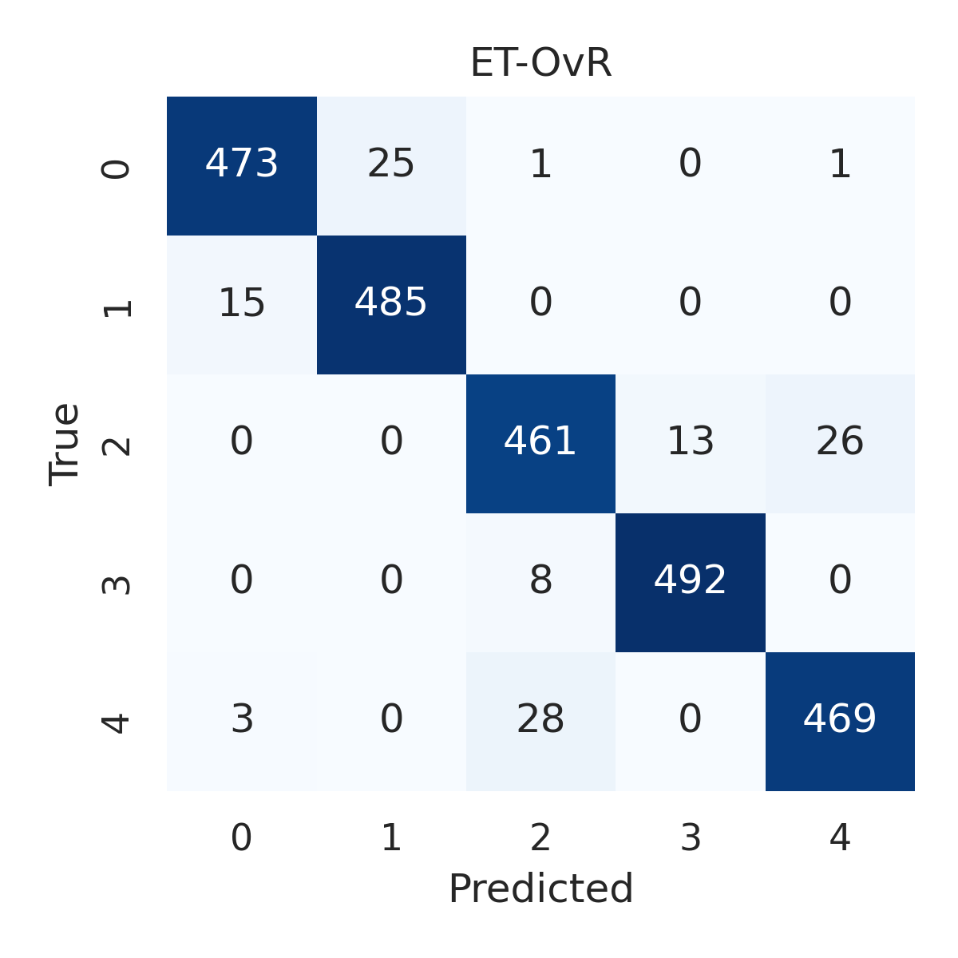

Combined ROC Curves
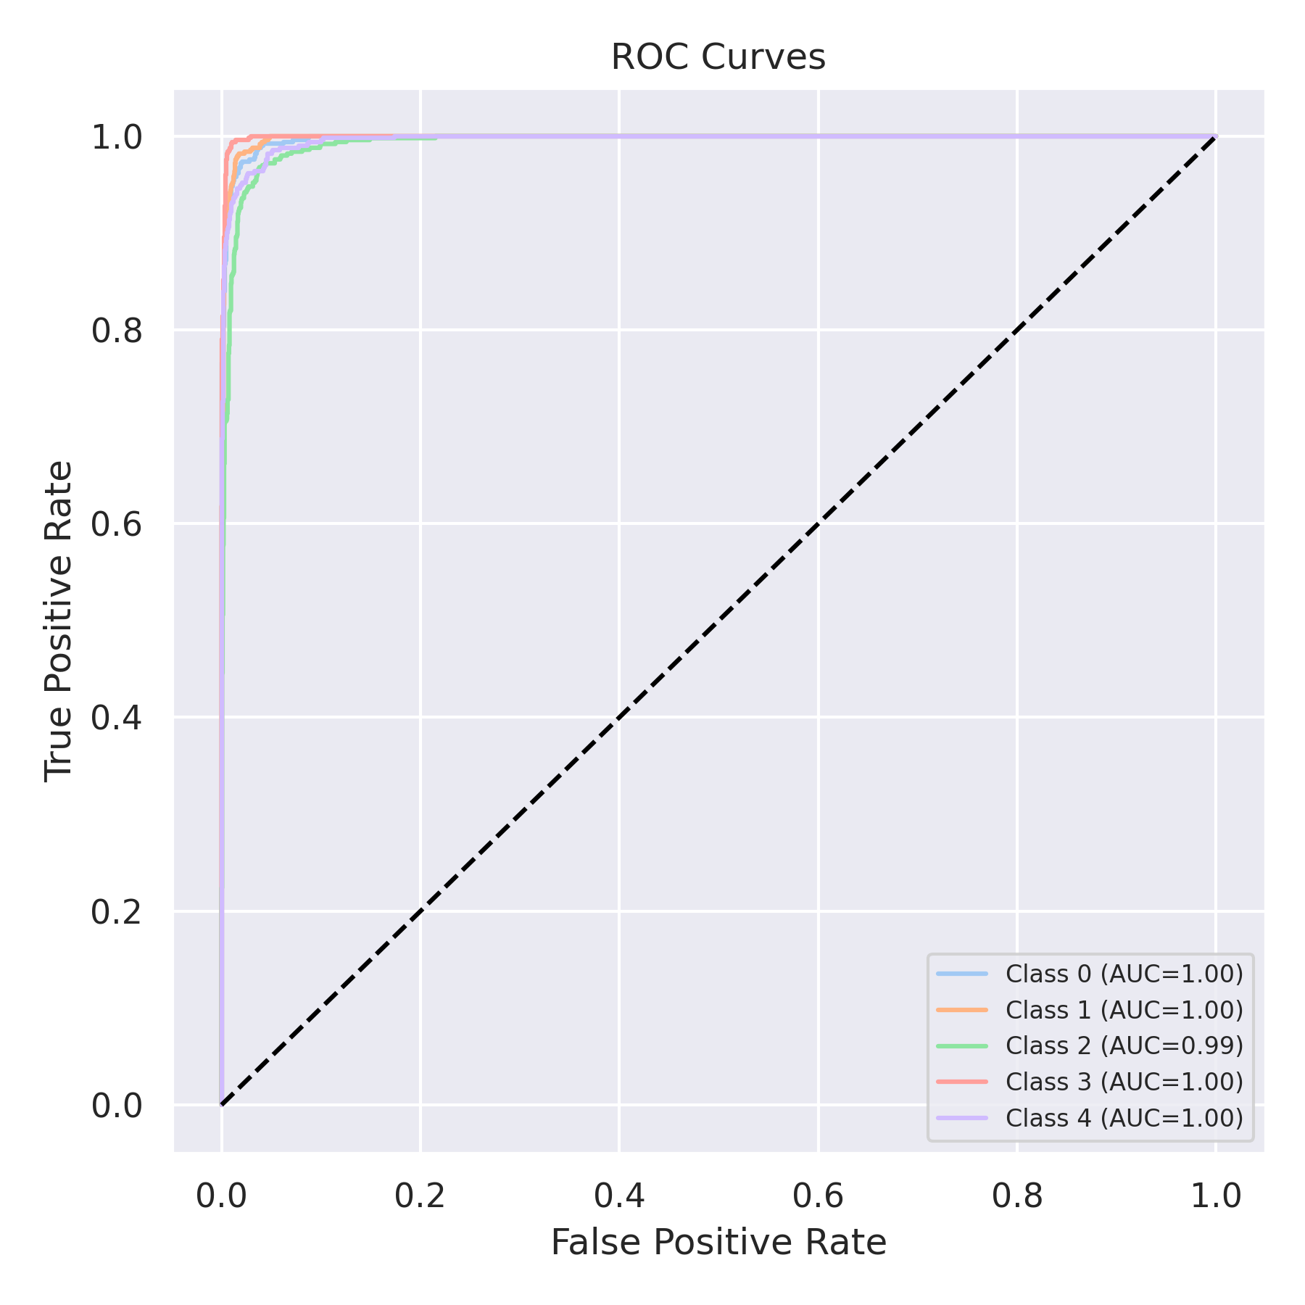

Evaluation: RF-OvR
Accuracy: 0.9444
Precision: 0.9442867942693832
Recall: 0.9444
F1 Score: 0.9443047756048609
Jaccard Index: 0.8952616168099005
Matthews CorrCoef: 0.9305191688923208
Cohen’s Kappa: 0.9305
Specificity: 0.9861000000000001
AUC: 0.9953745
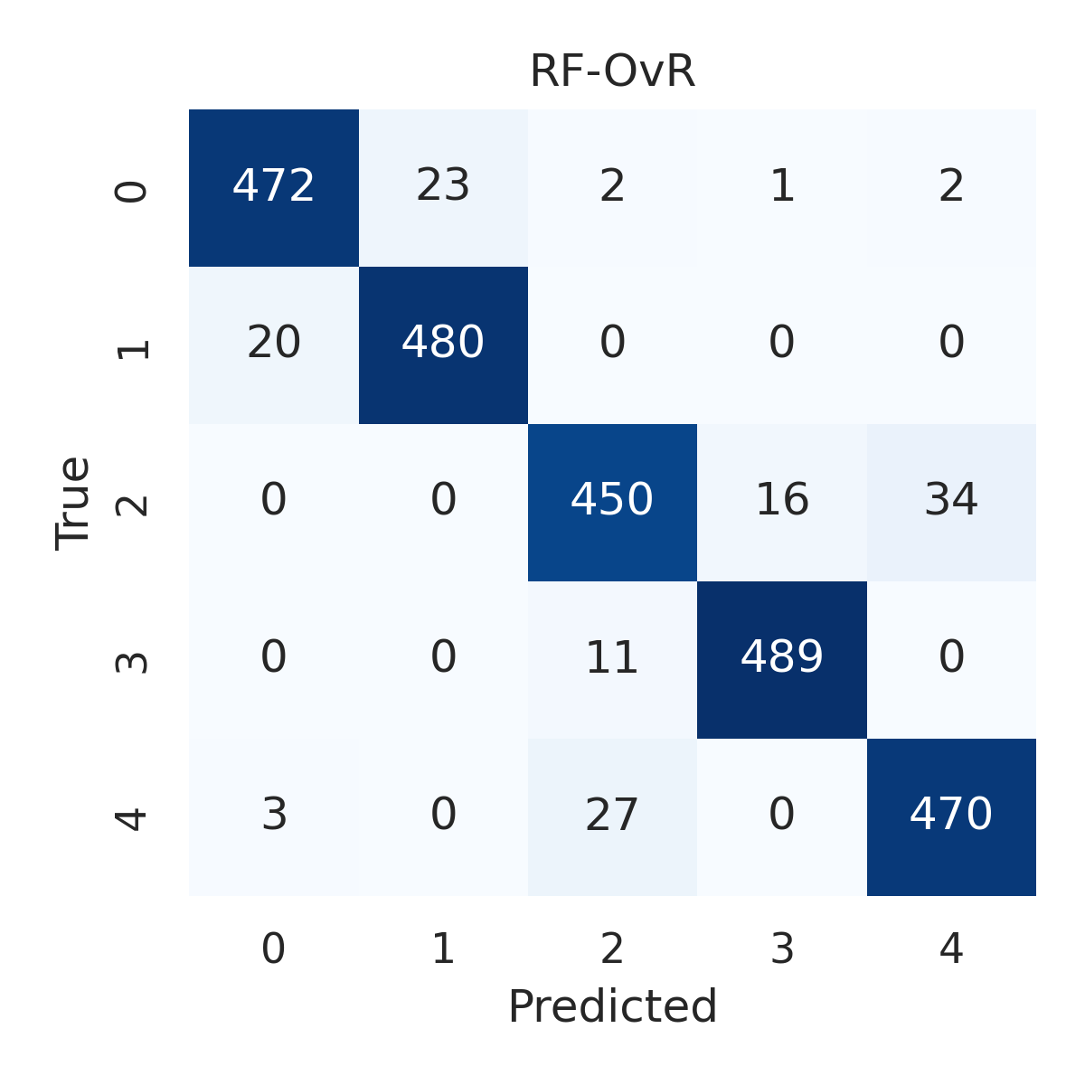

Combined ROC Curves
